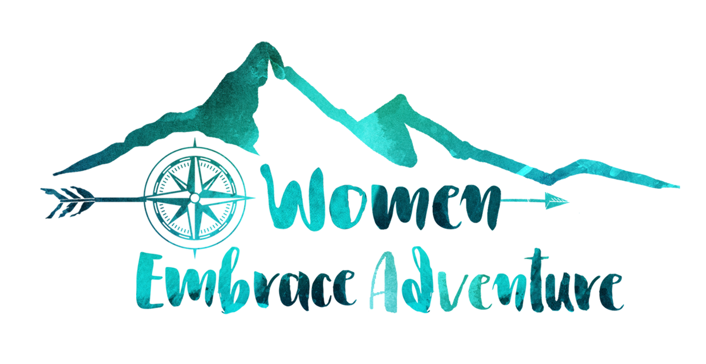
Women Embrace The Snowy Mountains Itinerary

Join Women Embrace Adventure for a fully guides, all-inclusive, 5 night/6 day Snowy Mountain walking adventure.

We spend 5 days walking 58kms in The Kosciuszko National Park which features the highest mountains in Australia, so a good level of fitness is required for this tour. Fabulous granite formations, green alpine meadows filled with wildflowers and broad views in all directions make for an excellent walking holiday in the Snowy Mountains. Take the opportunity to escape and explore our alpine environment with like-minded women!

DAY 1
Make your own way to our accommodation (The Crowne Plaza) in Canberra by 5 pm. This evening we will get to know each other over a couple of glasses of wine and a delicious Welcome Dinner.
Meals: Dinner

DAY 2
7km (easy to moderate) - 2 hours approx
After a delicious buffet breakfast, we will be picked up from our accommodation at around 8 am. After a couple of hours travelling, we stop at the Hydro Discovery Centre in Cooma where after watching a short film and a enjoy morning coffee. Then it's straight to our Lodge style accommodation. After lunch, we get organised for the first walk of the tour. Today’s walk follows alongside the cascading, icy waters of the Thredbo River from Dead Horse Gap back into Thredbo Village. On this signposted river track walk, you will see gums growing around granite boulders and watch the river race beneath your feet as you cross the footbridges. Stroll through the snow gum woodlands and enjoy the views down to the river. Keep your eyes on the river for trout and platypus – look for circular ripple patterns.
Upon return to our accommodation, you settle in for pre-dinner nibbles, followed by a delicious two-course dinner prepared by your Park Trek guides.
Meals: Breakfast, Lunch and dinner

Day 3

12km (moderate to hard) - 5 hours approx
After breakfast and lunch making we depart the lodge and head out for a delightful walk to the Porcupine.

Starting at the Perisher Valley Reservoir, this 5 km (2 hours) walk heads up through Rock Creek valley to the panoramic views from Porcupine Rocks. On this walk, you will wander through button grass plains and among groves of snow gums whilst passing some granite tors. From the top of this walk, there are magnificent views down both Perisher Valley and Thredbo River Valley as well as to Mt Duncan.
Rainbow Lake is our next destination. There are some gentle climbs and small creeks to cross before catching first glimpses of sun sparkling upon Rainbow Lake, but it’s all part of the adventure.
Here we can take our pick of lakeside picnic spots and bask in the sunshine while enjoying our lunch.

During the next 6 km walk, you’ll pass through a variety of settings, including tall eucalypt forest, outcrops of hefty granite boulders, and flowering and fruiting heathland. Then, of course, there’s the waterfall itself, which is wonderfully peaceful. Head to the platform on the south side for great scenic views. Be sure to check out the tall, fibrous -barked alpine ash trees nearby, which were logged in the area late last century and can grow to 90m tall.

Then it’s off to Kosciusko Education Centre at Sawpit Creek to view a range of hands-on displays and innovative programs to engage visitors wanting to learn more about the natural, cultural and historic heritage of Kosciuszko National Park. Back to the Lodge for the evening and a two-course dinner prepared by your guides.
Meals: Breakfast, lunch and dinner

DAY 4
13km (moderate to hard) - 5.5 to 6 hours
After breakfast and lunch making, we head out for our walk to Charlotte’s Pass. Today’s walk sees us walking along a well-formed track up to Carruthers Peak enjoying superb views of Lake Albina and Blue Lakes.

After rock-hopping across the Snowy River below Charlotte Pass, we have a challenging climb up to the top of the Main Range through alpine herb fields past Hedley Tarn Lookout to Blue Lake Lookout. Blue Lake is arguably the jewel in the crown of the Kosciusko National Park. It then climbs Carruthers Peak which provides spectacular views over the western slopes of the Main Range. It continues along the exposed ridge of the Main Range above Club Lake and Lake Albina until it meets the Summit Walk between Rawson Pass and Mt Kosciuszko. It is a challenging day of walking and we return to the Lodge in the afternoon for some well-deserved nibbles followed by a lovely two-course dinner prepared by your guides. Meals - Breakfast, lunch, dinner

DAY 5
18km (moderate – hard) – 8hours
After breakfast and lunch making our day starts with a bit of a difference. We’ll make our way to the highest point in the country, Mt. Kosciuszko. We take a chairlift ride to the top the Thredbo ski fields, walk to the top of Mt. Kosciusko and return via Merrits. Enjoy the chair lift from Thredbo Village to Main Range. Pass snowdrifts that survive year-round and soak up the awesome splendour of our surrounds on top of Mt. Kosciuszko.

Our return journey follows along a beautifully shaded trail that affords us superb views over the southern end of Australia’s High Country. Tonight, we have our celebration dinner and dine at a local restaurant.
Meals; Breakfast, lunch, dinner

DAY 6

8km (easy) - 2 hours approx
After breakfast, we pack up our belongings and the guides will pack the trailer. This morning we take a walk alongside the river from Thredbo Diggings. It is a short leisurely walk. Wallabies and kangaroos are also a common sight along the track. Be sure to keep a lookout too for platypus in the pools.

Lunch is at the Wildbrumby Kitchen cafe in Crackenback

We are usually back in Canberra around 4.30 pm and can drop you back to the airport around 5.00 pm. We say good bye to our new adventure friends!
Meals—Breakfast and Lunch

​

​

